General Changes:

* We need all figures re-done in colorblind friendly formats
  + Grayscale and a single-color hue for now, we will pick later
* We need all figures to be easily reproduceable via a GitHub repo
* We need titles to be re-done to be higher quality
* Larger fonts / readability when scaled to the sizes below
* All images must be higher resolution and scalable
* Color for scenarios must be consistent (so if BaU is dark blue in fig 1, that’s its color for all figs)

Figure 1:

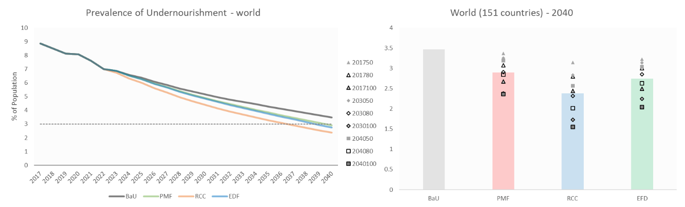

* Line Graph
  + We want the same data + style for line graph. Just Implement the changes described in “General Changes”
* Bar Graph
  + We want the data broken up by scenario then percentile target outcomes (50/80/100)
  + Legend will be changed to just be years (2017, 2030, 2040) and be marked on each percentile target outcome
  + A dashed line showing average across all percentile target outcomes (this may be dropped later)

Figure 2:

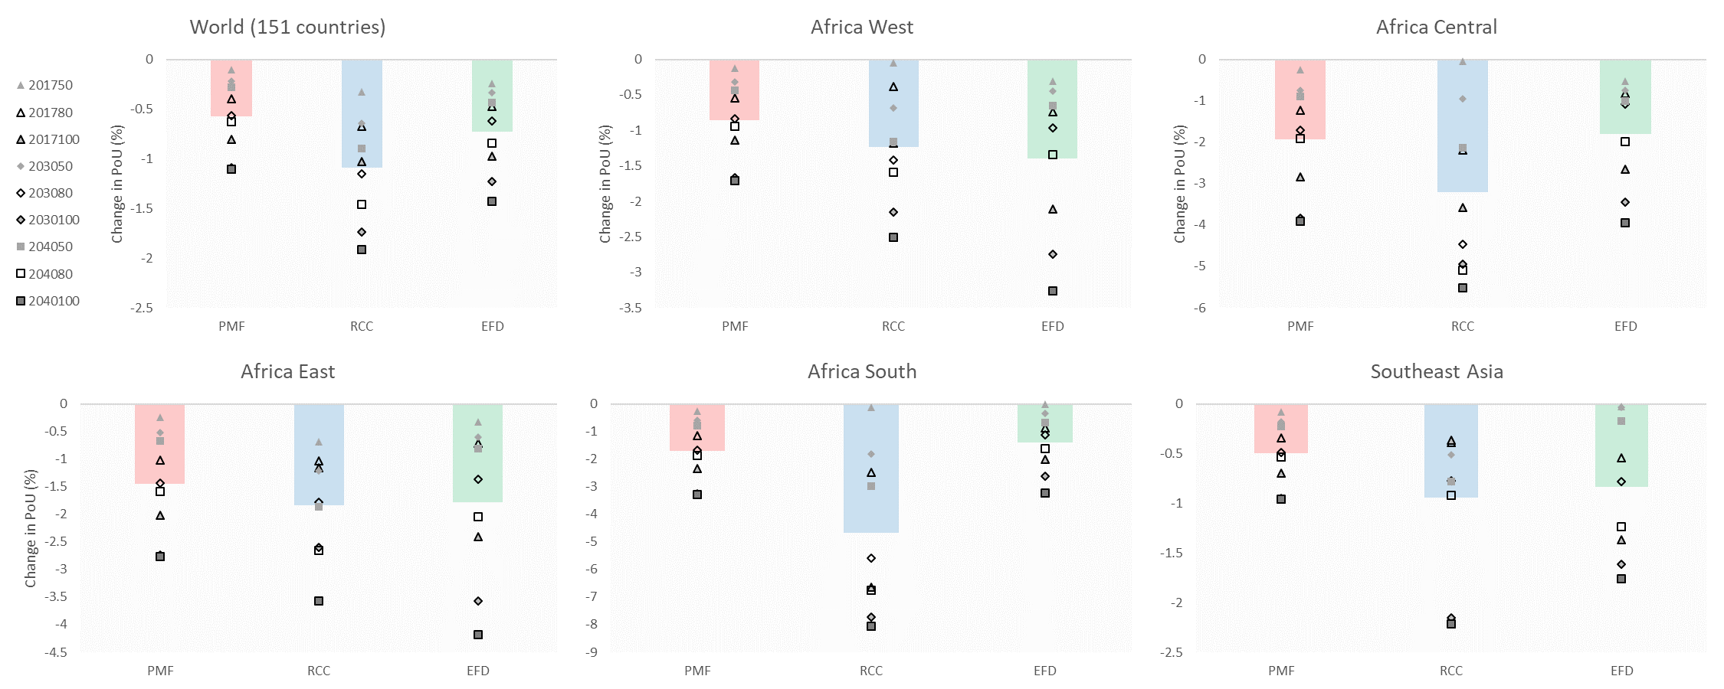

* We need two of this made:
  + One with every region + World
  + Second with only the five regions above + world
* These will then be restyled to be the bar graph described in figure 1

Figure 3:

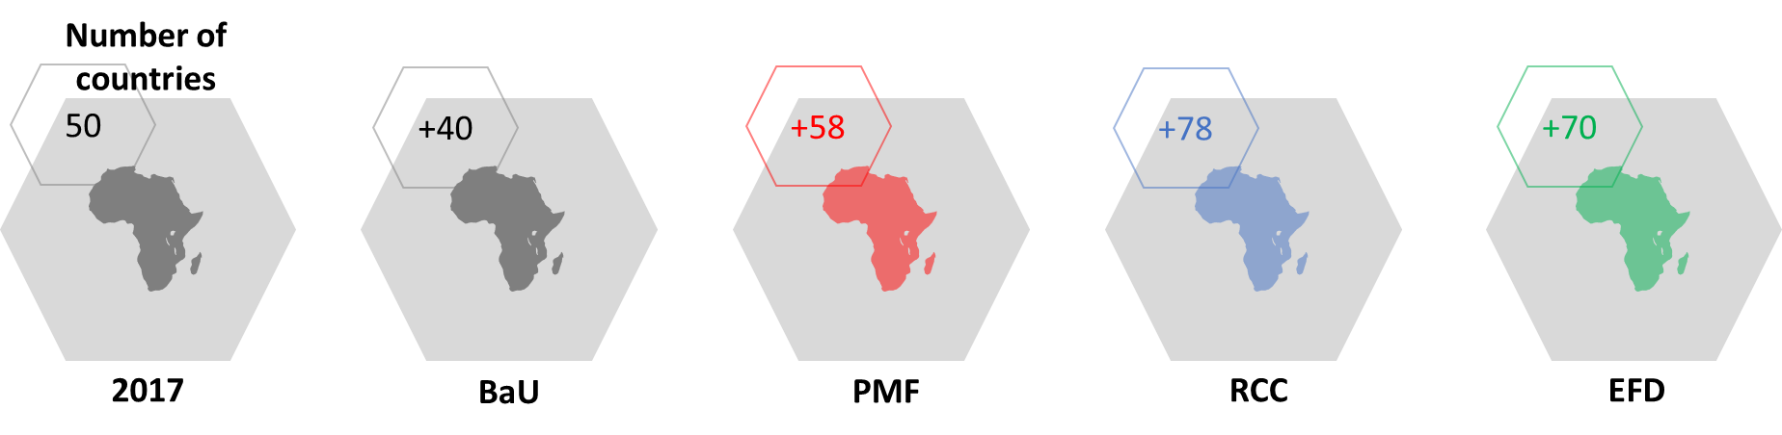

* Changed to be a World (not Africa)
* One other potential change:
  + The “+40/+58/etc.” means nations in the world that now meet the 3% undernourishment target
    - We may want this to be done by continent with separate numbers with pointers to their region
* This is an overwhelmingly photoshop project, not much for visualization